**Screenshots**

Screenshots are an important way to show evidence of your work. By creating an image yourself, you also avoid the problem of copyright infringement. Here are two ways you can make screenshots:

**Snipping Tool**

Windows has a screenshot tool in its main menu.

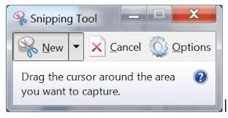

The snipping tool allows you to highlight and annotate the image:

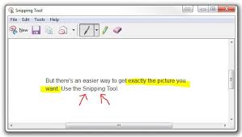

**Awesome screenshot**

You can get a free add-on to your Chrome browser called Awesome Screenshot which comes with a range of annotating options (highlighting, arrows text box) :

